……………...…………………………………………………………………………………….....
OpenMRS Implementation: A Report
by Zakia Salod (208501583)
UKZN – Faculty of Management
School of Information Systems & Technology
Medical Informatics Report
Lecturer: Mr. Yashik Singh

OUTLINE
- Introduction.
- OpenMRS.
- What is OpenMRS.
- Deployment.
- Community.
- The Generic Database Model.
- What is Generic Database Model.
- The Generic Database Model Used By OpenMRS.
- An Overview.
- Design & Procedure.
- The Development & Implementation Paradigm.
- The Opensource Developmental Model.
- Background & Overview.
- Advantages.
- Risks & Costs.
- OSS Development Process.
- Examples of Opensource Software.
- Within The Context of OpenMRS.
- Screenshots.
- Conclusion.
- References.
- Appendix.
……………...…………………………………………………………………………………….....
……………...…………………………………………………………………………………….....
OpenMRS Implementation: A Report
by Zakia Salod (208501583)

Abstract

Open Medical Record System (OpenMRS) is a highly configurable open source electronic medical record system. It was developed and maintained by a network of open source developers inspired to use information technology to bring about effective change in managing patients’ medical records in developing countries. It is mainly used to manage patients and their treatment records in the areas of HIV/AIDS and tuberculosis (TB). It is widely used in Africa, which records the highest rates of HIV/AIDS and TB.

OpenMRS is an easy to use application that can be used as a standalone application on a single computer or as a client-server application in a multi-user environment. It is software built on a generic database model wrapped into an Application Programming Interface (API) and can easily be configured and implemented by Implementers with little programming skill and without the need to actually program.

Using OpenMRS, clinicians in developing countries can now use information technology to better manage patient medical information, allowing them to make better decisions and provide better medical care.

- Introduction.
Maintaining medical information is an increasing important factor in providing effective health care for people suffering with HIV/AIDS and tuberculosis. Effective information management of patient information would not only solve administration problems, but provides clinicians with better means to make smarter decisions and provide improved health care for patients given a patients proper medical history.
In Africa, these needs were the greatest in which under developed countries suffer the most with the highest rates of HIV/AIDS and tuberculosis. This coupled with the expensive cost of purchasing commercial Medical Record Systems (MRSs) makes it infeasible for countries and organizations to invest in software when the need to supplement health care is of a greater importance.
With this in mind, software developers at the Regenstrief Institute (Indianapolis, USA) in partnership with Partners in Health (Boston, USA) saw an opportunity to use open source information technologies to create a highly efficient, enterprise level medical record system that was aimed at bridging the gap between medical professionals, patients and information management in developing countries. This system is called OpenMRS.
This report reviews OpenMRS, its purpose, its implantation, its growth and its design. It also covers the OpenMRS Implementers Network which provides support for Implementers using OpenMRS in their regions of application.

- OpenMRS.
A. What is OpenMRS.
OpenMRS is an open-source, encounter-based Electronic Medical Record (EMR) system developed to aid in the delivery of health care in developing countries. This system arose in response to the growing need of improving the treatment of the HIV/AIDS pandemic.
Indiana University School of Medicine and Moi University Faculty of Health Sciences (Eldorate, Kenya) were the two parties that served as the pioneers of this project. Both these universities were in collaboration for over a decade, when their focus of attention turned, by necessity, to the HIV pandemic (Mamlin, 2006). At the time, a relative amount of work was needed to accomplish the task, yet there were limited resources available and existing systems were overburdened. It was evident that HIV is a treatable disease, but treating millions of inflicted individuals required effective management of information. After much research, it was decided upon that a system would be built to accomplish the required goals.
The leading individuals, Paul Biondich and Burke Mamlin from the Regenstrief Institute, Indiana, were introduced to the EMR team at Partners in Health led by Hamish Fraser and Darius Jazayeri. Fraser and Jazayeri were searching for ways to scale up the EMR web-based medical record system, which was developed to manage drug resistant tuberculosis in Peru, and HIV in rural Haiti. Thus, when Paul, Burke and Hamish met in September 2004 at the MedInfo conference in San Francisco, they realized that they shared a similar philosophy for healthcare and development. They had decided to collaborate on a shared EMR and this led to the birth of OpenMRS.
B. Deployment.
The first deployment of the OpenMRS system was in Eldoret, Kenya in February 2006. This was followed by the PIH hospital in Rwinkwavu, Rwanda in August 2006 and Richmond Hospital in KwaZulu-Natal, South Africa. At present, OpenMRS is in use by at least twenty three developing countries, the majority being in Africa, and it has been used to record approximately one million patient records around the world (OpenMRS, 2011).

C. Community.
The OpenMRS community consists of various individuals such as programmers, implementers and users from various countries who collaborate through different forms of communication mediums like mailing lists and IRC. OpenMRS was a key participant in the Google Summer of Code sponsorship in the years 2007, 2008, 2009 and 2010. According to the sponsorship’s program manager, OpenMRS receives more student applications than that of another prominent open-source project, the Apache Software Foundation (OpenMRS, 2011).

- The Generic Database Model.
A. What is Generic Database Model.
The Generic Database Model is a database design that treats associations between things as things themselves (Collins, 2000). Attributes are viewed as being things and are often reflective of a particular view of a thing. Generic modelling can be supported by a data storage system that is also generic. The combination of generic modelling and generic storage provides a data structure which is highly adaptive to change.
Particularly, the Generic Database Model design is currently in prominent use in the development of EMR solutions. This is due to the benefits evident in this design. The Generic Database Model counteracts the issue of the inevitable changing needs of users by its vertical growth, instead of horizontal, which is usually the norm in other database designs. In addition, the Generic Model increases the number of rows and not columns. This type of growth counteracts the size limitation of other types of database designs.
B. The Generic Database Model Used By OpenMRS.
1. An Overview.
In view of the fact that a robust, explicit representation of health care information is necessary for any electronic medical record system, the OpenMRS collaborative invests continuous efforts into shaping its data model (OpenMRS, 2011). This is achieved through the knowledge and experience obtained from practical experiences from the Regenstrief Institute, Partners in Health, and other development partners globally. The core of this model addresses the questions of who, what, when, where and how of medical encounters (OpenMRS, 2011).
Figure 01 clearly displays the data model structure of the OpenMRS project.

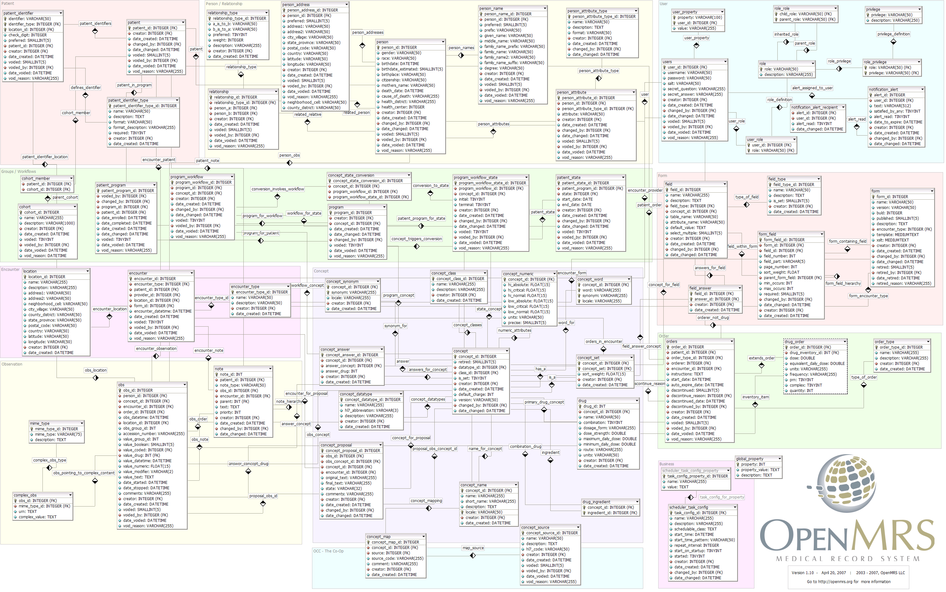
Figure 01: The OpenMRS Data Model (adapted from Mamlin, 2006)

This model is divided into ten basic domains. The domains are tabulated in Table 01 below.
No. | Domain | Description
1 | Concept | Concepts are defined and used to support strongly coded data throughout the system.
2 | Encounter | Contains the meta-data regarding health care providers interventions with a patient.
3 | Form | Essentially, the user interface description for the various components.
4 | Observation | This is where the actual health care information is stored. There are many observations per Encounter.
5 | Order | Things/actions that have been requested to occur.
6 | Patient | Basic information about patients in this system.
7 | User | Basic information about the people that use this system.
8 | Person | Basic information about person in the system.
9 | Business | Non medical data used to administrate OpenMRS.
10 | Groups/Workflow | Workflows and Cohort data.
Table 01: The OpenMRS Data Model Domains (adapted from OpenMRS, 2011)

2. Design & Procedure.
The OpenMRS data model is based on a “concept dictionary”. An example of a “concept dictionary” is shown in Figure 02 below. A “concept dictionary” describes all the data items that can be encompassed in the system such as diagnosis, tests, procedures, drugs, clinical findings, laboratory test results, socio-economic data or other general questions (Danka et. al., 2010). This approach avoids the need of having to modify the database structure to add new data, for example, the addition of new diseases. It facilitates sharing of data dictionaries between projects and sites. After the encounter with the concept dictionary, forms are then created by the use of concept-value pairs, in which a value can be associated with a concept, for example, Blood Pressure 120/90 (Danka et. al., 2010). The interface allows for a doctor to view a particular encounter or graph of concept(s). These two activities are done on two separate tabs. Although such a data structure is useful for data collection, the user interface for the data does not represent the data in an integrated and meaningful way to the clinician. This is shown in Figure 03 below.
Concept | Units
Pulse | bpm
Weight | lbs
Figure 02: An Example of The OpenMRS Concept Dictionary (adapted from Mamlin, 2006)
Figure 03: The OpenMRS Encounter List, Encounter Form, Graphs (adapted from Danka et. al., 2010)

- The Development & Implementation Paradigm.
A. The Opensource Developmental Model.
1. Background & Overview.
The software industry has far seen the discussion and analysis of two prominent methodologies in software development, seemingly, since time immemorial. Propietory software and Open Source Software (OSS) are these two prominent methodologies in existence within the software industry and remarkably, the debate between the two continues, even today. Proprietory software, also known as closed-source software, is an application that is produced by an individual or an organization and has major restrictions imposed in the use of it. For example, the source code of proprietory software is reknowned to be kept secret by the developers of such a software product. In contrast, with OSS, also known as Free Software (FS) or public domain software, no cost is attached to the availability of the application, it can be used publicly, can be modified, and redistributed with minimal restrictions imposed on it. The most prominent characteristic of OSS is that the source code is freely available to the public.
2. Advantages.
The most important benefit that is associated with OSS is the public availability of the source code and the ability to modify it. This allows for improvements in the software, without restriction. It also enables portability of the code into different platforms, adaptations to different conditions and the ability to comprehend exactly how a particular system works. In addition, Gonzalez (2000) notes that source code availability makes it easier to isolate bugs and, accordingly, allow for programmers to easily detect and correct them.

OSS developers provide public rights to individuals and companies to redistribute modifications and improvements to the code. This deems beneficial as these modified and improved codes can be shared by large communities; as seen as a unique feature under OSS licences, compared to that of proprietary software (Gonzalez, 2000). This universal redistribution rights associated with OSS is one of the main factors that attract software developers to work on OSS projects, and thus, aid in improving the quality and functionality of such software products.

With OSS, no individual has the power to profess restriction on the manner in which OSS is used. This manifesto is evident in proprietary software products, in the case where the developers decide not to upgrade software for an older platform environment. In this case, the user is forced to use the older version of the software, or instead, switch to a different product (Gonzalez, 2000). However, with OSS, the user of the product may fund the development for the desired platform, or search for vendors to provide the required upgrade for the same software.

Black boxes are impossible with OSS. This is an imperative advantage, since it is related to the dependability of a software product. Availability of the source code, thus categorizing OSS as white box, enables a fair amount of inspection and verification of the correctness of the algorithm and the implementation scheme used (Gonzalez, 2000). Although some proprietary software may also be white box, with OSS, the users may modify any section of the code they desire to suite their needs. A prominent example of this is the Linux kernel, which has been through a number of modifications and enhancements, proving eventual success. Hence, it is evident that proprietary software proves ineffective since, although source code may be available, modifications are forbidden. OSS provides the source code and the freedom for users to modify it, proving that this approach is effective.

OSS is associated with minimal conflicting priorities, with respect to marketing pressures. This is the consequence of the fact that there is no single commercial entity that pushes for precise features or delivery dates to be supported by the software product (Gonzalez, 2000). The norm is that OSS is released into the market when the development team is sufficiently satisfied with the quality of the software product. Hence, unlike proprietary software, OSS reduces or completely eliminates the need for service packs updates. This, in turn, reduces OSS maintenance costs.

3. Risks & Costs.
Barret (2007) posits that there are a number of risks and costs associated with OSS, in terms of both development and use of the products. Some of these risks and costs are highlighted below.

OSS systems tend to be large and difficult to scale down. Thus, these software products may not yield optimum results like proprietary software can yield in terms of performance or footprint. The rationale for the large size OSS code is that there is no single champion for underlying principles like “small” or “efficient” since the code is expansive by the market. Hence, both in terms of use and development, the large size of OSS code deems inappropriate and impacts on maintenance.

Software created in the open source environment also does not meet a single individual’s or business’s needs. In other words, OSS does not span a range of application requirements and may not serve the needs of its user(s) in an optimal manner, in a customized way.

OSS is the most trusted piece of software since it is tested by a number of programmers and has reliable roots. However, due to the OSS community’s updating nature, software products may lead to unproven code. This is not conducive to building trust in OSS products. In contrast, proprietary software is reliable, robust and very trustworthy since the software is tagged under the company it is built from.

OSS requires integration and this falls under the system developer’s shoulder. This increases the development time of creating OSS products and thus, also increases risk. This is in contrast to proprietary software products which are already integrated, ported and run on a target platform of users that are the first to purchase them.

There is no specific entity or organization to turn to when there is a problem with the use of an OSS product. Users of OSS are likely to require correction and support of OSS they use, since there is a reasonable probability that the product may require some modification to work on a specific hardware and in the application itself. In this regard, the user could turn to a threaded discussion with OSS community, in the hope that someone can resolve the user’s issue(s). If a user had acquired the software from a company that provides OSS and sells support for it, the user could turn to the company if trouble or special needs arise. However, the cost of this support is likely to exceed the price of a licensed proprietary software product. Hence, there is a need for an opportunity cost to determine the perceived versus the actual worth of a software product, in terms of development and use.

OSS products make use of GPL, LGPL and other forms of open source licenses. These licenses associated with OSS could impose severe restrictions on what could be done with open source code. In addition, OSS developers could be legally obligated to expose their intellectual property such as application code, to anyone who wishes to have it – even competitors. Hence, OSS developers could hire an IP lawyer to protect their applications’ trade secrets on the side of the license. However, this leads to greater developmental costs for the software product.

It should be noted that although OSS products are “free”, there exists obvious and hidden costs along the way that could easily exceed the costs of fully licensed, proven and supported proprietary software products. As has been mentioned previously, costs associated with OSS product use may be hardware costs, support costs, legal costs and schedule costs. Thus, it is important to critically evaluate the choice of adopting the OSS methodology in the use and development of software products.

4. OSS Development Process.
OSS development is associated with its own type of development process, different to the prominent traditional life cycle model. In the traditional software development process, the development life cycle has four generic broad phases: planning, analysis, design and implementation. With OSS development, these stages are configured differently (Fitzgerald, 2006). The first three phases of planning, analysis and design are typically concatenated and performed by a single developer or a small core OSS group. The planning phase is best described by Raymond’s (1999) phrase of a single developer perceiving “an itch worth scratching.” This leads to the construction of a prototype. Since a large number of developers with different abilities should be able to contribute to the OSS product, the requirements analysis phase was superseded. Requirements are taken as understood in general and hence, the interaction among developers and end-users is not needed. Design decisions are made prior to the contribution of developers. The systems are generally highly modularized to allow for distribution of work and also, to reduce the learning curve for new developers (Fitzgerald, 2006). In addition, the implementation phase of the OSS development life cycle model consists of several subphases (Feller & Fitzgerald, 2002). These subphases are: code, review, pre-commit test, development release, parallel debugging and production release (Fitzgerald, 2006). The OSS development process varies with different projects in different aspects. For example, there exists varying degrees of formalism as to how decisions are made, but the principle of “having a tail-light to follow” (Bezroukov, 1999) captures the spirit well. The norm is that the initial software developer or the core group responsible for the initiation of an OSS product makes the key decisions in accordance with the process outlined in the life cycle above.

5. Examples of Opensource Software.
A list of the main open source software is listed below (Seebregts et. al., 2009 & OpenMRS Technical Overview, 2011).
  - MySQL – This is a relational Database Management System (RDBMS) used to store the applications information (www.mysql.com)
  - Apache Tomcat – Server Application (http://tomcat.apache.org/)
  - Mozilla FireFox – Web browser Application (http://www.mozilla.com/firefox/), although other web browsers can be used
  - Hibernate – This is a layer above MySQL which allows mapping to other relational databases (http://www.hibernate.org/)
  - Spring MVC – Framework for internationalization (http://www.springsource.org/)
  - Dojo – Javascript library and packaged system (www.dojotoolkit.org/)
  - DWR – Translates Java methods and object to Javascript methods and objects (http://directwebremoting.org/dwr/index.html)

B. Within The Context of OpenMRS.
OpenMRS is a multi-layed web based application. Its core is a Java (http://www.oracle.com) application which is built using Java and Javascript and other open source software which runs on a Java platform. The architecture of OpenMRS is shown below in Figure 04.
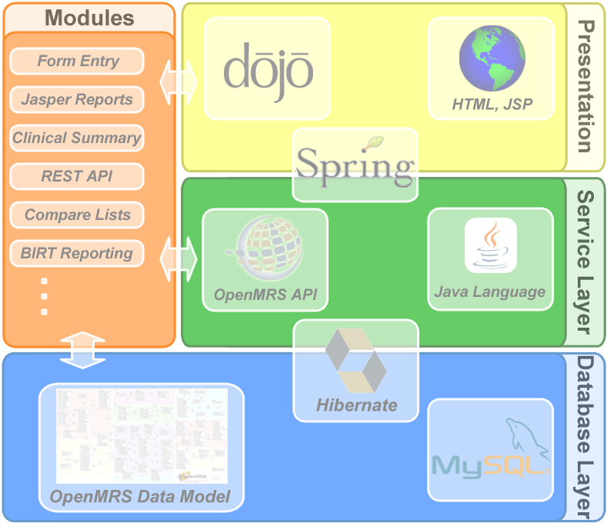
Figure 04: The OpenMRS Tiered Architecture (adapted from OpenMRS Architecture, 2011)

Even thought this is the main architecture of OpenMRS, extra modules can easily be added to its core application to provide additional functionality. This ability to plug and play modules makes OpenMRS very flexible in being able to add modules without disrupting the base platform.
Almost all OpenMRS installations use the FormEntry module. This module allows forms to be developed, which are used to capture data. The software used to design and implement forms at this level is InfoPath (Microsoft Corporation). This is a commercial application that has very effective and easy to use means of facilitating data entry. Two main advantages of using InfoPath are (Seebregts et. al., 2009):
- It uses XML and follows a very clean Model-View-Controller (MVC) pattern that allows the data elements being collected being collected to be managed separately from the forms.
- It provides a What You See Is What You Get (WYSIWYG) editor. This allows for easy editing and can be used by non-programmers.
When information is entered into the application, it is stored in the RDBMS. It can then be queried using Structured Query Language (SQL) (Seebregts et. al., 2009).
OpenMRS can be used as a stand alone web application or as a multi-user client server web application. Due to this, OpenMRS can operate across a Local Area Network (LAN) or in a more widely distributed manner across the internet.
OpenMRS implements several standards to supports its functionality as a client-server application and to improve interoperability with other systems (Seebregts et. al., 2009). Form entry is represented using Extensible Markup Language (XML) and XForms (XML Forms) standards. Data is communicated between the FormEntry module and the API as Health Level Seven (HL7) messages (Seebregts et. al., 2009).
OpenMRS can be configured and implemented by Implementers. Implementers by definition in terms of OpenMRS standards are, “Health information system professionals who focuses on installing and configuring software and systems to meet the needs of a particular health information system requirement with little or no programming of the actual software application” (Seebregts et. al., 2009, p. 3). The ability to have Implementers implement OpenMRS in regions of developing countries that lack programming expertise makes OpenMRS very feasible on a scalable level. Support for Implementers is provided by the OpenMRS Implementers Network. This network has a dedicated Wiki Site and an e-mail server to help Implementers with implementation problems. Any programming implementation problems are handled by the open source community volunteers.

- Screenshots.
The Maternal Death Notification DOH form was implemented using the HTML Form Entry approach. Screenshots of this implemented system are shown in the accompanying figures below.
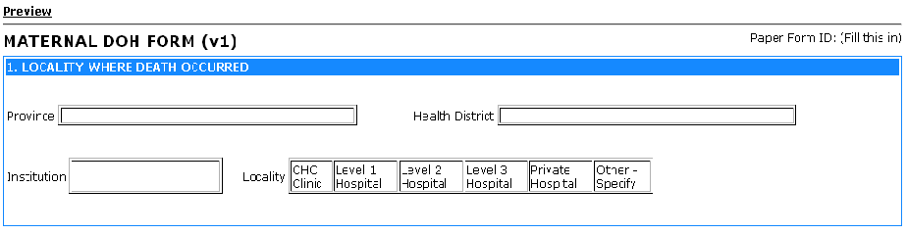
Figure 05: Screenshot of the Locality Where Death Occurred section of the Maternal Death DOH implemented form

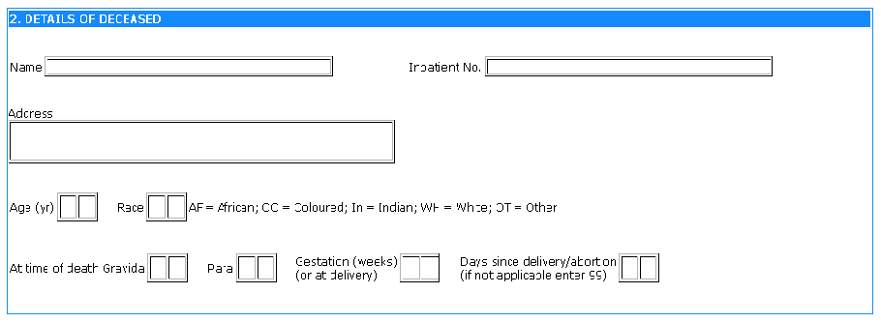
Figure 06: Screenshot of the Details of Deceased section of the Maternal Death DOH implemented form

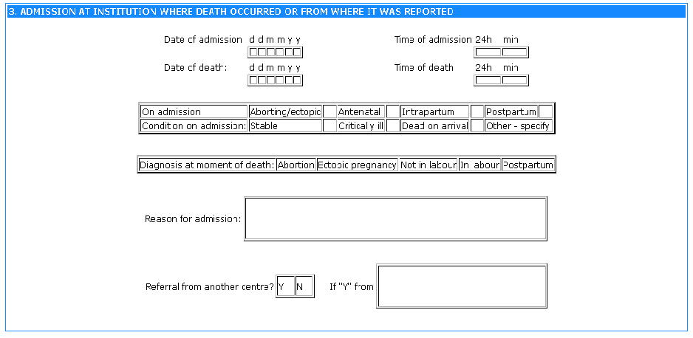
Figure 07: Screenshot of the Admission At Institution Where Death Occurred Or From Where It Was Reported section of the Maternal Death DOH implemented form

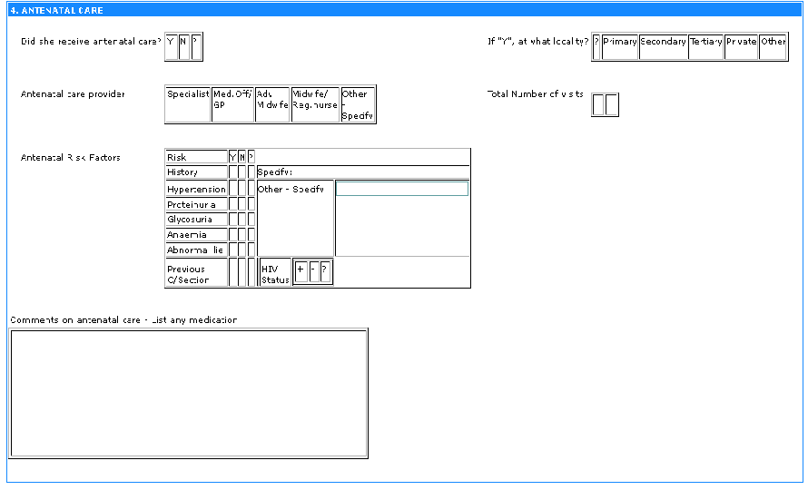
Figure 08: Screenshot of the ANTENATAL CARE section of the Maternal Death DOH implemented form

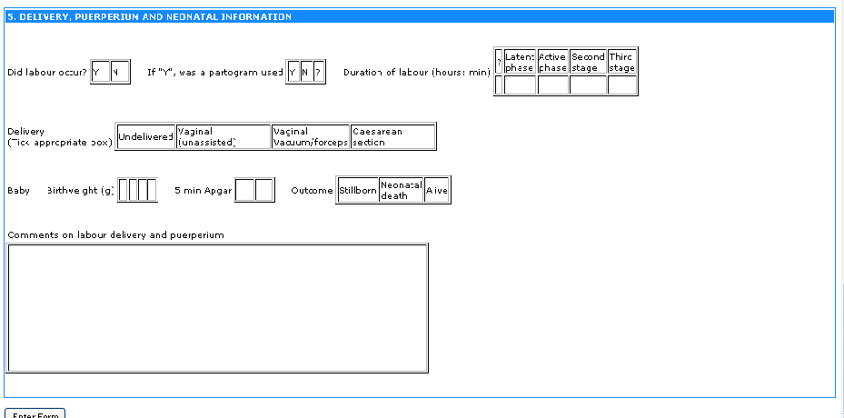
Figure 09: Screenshot of the DELIVERY, PUERPERIUM AND NEONATAL INFORMATION section of the Maternal Death DOH implemented form

- Conclusion.
OpenMRS is a highly configurable open source medical record system. It is developed and maintained by a community of open source developers who saw a need to use open source information technology to meet the need of having patient medical records being recorded and used in a more effective and electronic way. OpenMRS is a very easy to use, modularized application that can be used and implemented by Implementers with minimal computer skills. It is mainly used to record patient information for patients suffering with HIV/AIDS and tuberculosis. It is mainly used in developing African countries where the need to supplement health care is greater then the need to invest in commercial Medical Record Systems software.
OpenMRS is a web based application that can either be used on a stand alone basis or in a multi-user client server environment. Its core design stores medical information in a RDBMS that is wrapped in an API. Because of its flexible and modular structure, modules can easily be added in a plug and play fashion without disrupting the base platform of the application. This allows for easy configurability and implementation in different regions of application.
The OpenMRS is equivalent in standards with other commercial software applications. The mission of OpenMRS is to improve health care in developing countries through information technology, to effect change through collaboration, sharing of ideas and through action.

- References.
Bezroukov, N. (1999, October 1999). Open Source Software Development as a Special Type of Academic Research (Critique of Vulgar Raymondism). from http://www.firstmonday.org/issues/issue4_10/bezroukov/).
Collins, D. (2000). Generic Data Modeling. Retrieved 16 September 2011, 2011, from http://www.dama-nj.org/presentations/Kalido_Generic_Data_Modeling.pdf
Danka, M., Iosif, A., & Morrison, C. (2010). Report on existing open-source electronic medical records. Technical Report, 768.
Feller, J., & Fitzgerald, B. (2002). Understanding Open Source Software Development. London: Addison-Wesley.
Fitzgerald, B. (2006). The Transformation of Open Source Software MIS Quarterly, 30(3), 587-598.
Gonzalez, J. M. (2000). Advantages of Open Source Software. Retrieved 9 May, 2011, from http://www.linfo.org/proprietary.html
Mamlin, B. W. (2006). What is OpenMRS? Retrieved 13 September 2011, 2011, from http://www.slideshare.net/bmamlin/what-is-openmrs-in-3-min-with-captions
OpenMRS. (2011a). OpenMRS. from http://www.openmrs.org
OpenMRS. (2011b). OpenMRS Architecture. Retrieved 16 September 2011, 2011, from http://archive.openmrs.org/wiki/OpenMRS_Architecture
OpenMRS. (2011c). OpenMRS Technical Overview Retrieved 16 September 2011, 2011, from http://archive.openmrs.org/wiki/OpenMRS_Technical_Overview
Raymond, E. S. (1999). The Cathedral and the Bazaar: Musings on Linux and Open Source by an Accidental Revolution. Sebastopol.
Seebregts, C. J., Mamlin, B. W., P.G., B., H.S., F., B.A., W., D., J., et al. (2009). The OpenMRS Implementers Network. OpenMRS Implementers Network, 78(11), 711-720.
- Appendix.
A1. Paper-Based DOH Form – Maternal Death Notification – Page 01
A2. Paper-Based DOH Form – Maternal Death Notification – Page 02
END OF DOCUMENT
……………...…………………………………………………………………………………….....

